Mmmmmm and Nnnnnnnn of Xxxxxxx Yyyyyyy

Author Aª, Author B^{b} and Author C^{c}
ªAcademy of Mathematics and Systems Science
Chinese Academy of Sciences, Haidian, Beijing 100190 China
ªaaaa@amt.ac.cn
^{b, c}Department of xxxxxxxxx
University of Tsukuba, Tsukuba, Ibaraki 3058577 Japan
^{b}bbbb@sk.tsukuba.ac.jp, ^{c}cccc@sk.tsukuba.ac.jp

Abstract

xxxxxxxxxxxxxxxxxxxxxxxxxxxxxxxxxxxxxxxxxxxxxxxx.

Keywords: Keyword 1, keyword 2, keyword 3, last keyword.

1 Introduction

Please use A4-sized page format. The text height and width should be 235 mm and 165 mm, respectively.

2 Typeface and Size

For the main text, please use 11-point Times and single-line spacing. The text should always be justified.

3 First-Order Headings

First-order headings (sections) should be 12-point Times, and enumerated using Arabic numbers. The first letter should be capitalized, and lower case letters are used for the rest.

3.1 Second-order headings

Second-order headings (subsections) should be 11-point Times, and enumerated using Arabic numbers. Only the first letter of second-order headings should be capitalized.

3.2 Xxxxxx yyyyyy zzzzzz

xxxxxxxxx xxxxxx xxxxxx xxxxx xxxxx xxxxx. xxxxx xxxxx xxxx xxxxx xxxxxx xxxxx xxxxxxx. xxxxxxxxxxxxx. xxxxxx xxx xxxx xxxxxx xxxxx xxxxxx.

4 Equations

Equations should be centered. Please use Arabic numbers for numbering of equations. An example is as follows:

(1)

5 Figures and Tables

Figures and tables should be centered. Both figure and table captions should be 11-point Times. Figure captions should be centered and placed below the figures, while table captions should be centered and placed above the tables. Figures and tables must be numbered separately using Arabic numbers.

Their examples are as follows:

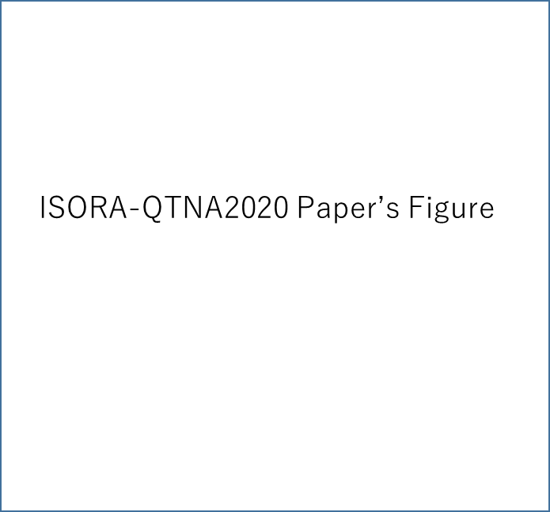

Figure 1: An example.

Table 1: An example.

Data 1 | Data 2 | Data 3 | Data 4 | Data 5
Value 1 | Value 2 | Value 3 | Value 4 | Value 5

6 Conclusion

xxxxxxxxxxxxxxxxxxxxxxxxxxxxxxxxxxxxxxxxxxxx.

Acknowledgment

This work was supported in part by xxx, xxxxxx.

References

[1] http://ecoweb.co.zw/computing/zimisis.aspEB/OL/.

[2] X. Wxxxxx, “A xxxx ccccc zzzzz: Oxxxx cccccc gggggg ssssss,” Journal of Xxxxxxx, vol. xx, no. xx, pp. xx-xx, 19xx.

[3] Z. Hhhhh and Y. Yyyyyy, Pooooooo Dddddd of Zzzzzz-Aaaaaa and Xxxxxxx Wwwwww. Klumer Academic Publishers, 19xx.

[4] H. Lhhhh and M. Hxxxx, “Pxxxxxxxxxxx tttttttttt of ssssssss nnnnnn kkkkkk,” Ccccccccc Journal, vol. xx, no. x, pp. xx-xx, 20xx.

[5] W. Aaaa, H. Tttt and K. Sssss, “Aaaaaaa cccccc for bbbbb tttttttt uuuuuuu vvvvvv sssss AMS,” in Proc. 20th International Conference of Nxxxxxxxxxxx Rrrrrrrrrrrr and Mmmmm, pp. xxx-xxx, 20xx.

